API SPERCIFICATION AND EXAMPLE Document

Airbus Detection API Function

Team 1 API

User Guide

Table of CONTent:

Contact Information and Dataset Insights …..…………………………2

API Functions:

Function 1: Get Image and Masks……………………………………………………..5

* Description
* Example

Function 2: Get Run Length Decode……………………………………………..…..7

* Description
* Example

Function 3: Get ship and non-ship image……………………………………..…..9

* Description
* Example

Function 4: Get Number of Images that has Certain Number of Ships………………………………………………………………………………………………………11

* Description
* Example

Function 5: Get Image Directly from S3…………………………………………….12

* Description
* Example

Function 6: Get Number of Ships in an Image ………………………..…………14

* Description
* Example

Contact Information

Team member 1:

Name: Adina Nibijiang

Email: [adina.n@northeastern.edu](mailto:adina.n@northeastern.edu)

TeAM MEMBER 2:

Name: Zifeng Jiang

Email: [jiang.zif@northeastern.edu](mailto:jiang.zif@northeastern.edu)

Dataset Insights

There’re 2 CVSs and 2 folders. But we will be mainly focusing on tran_ship_segmentation_v2.csv and tran_v2 folder. 

In tran_ship_segmentation_v2.csv there’re 2 columns, one is image id and the other one is Encoded Pixels.

Total records in the train set: 231723

No. of images with no ships: 42556

No. of images with ships: 150000

train_ship_segmentation_csv insights Bar Plot :

In tran_v2 folder, there’re 27GB JPGs.

Sample Images with ships

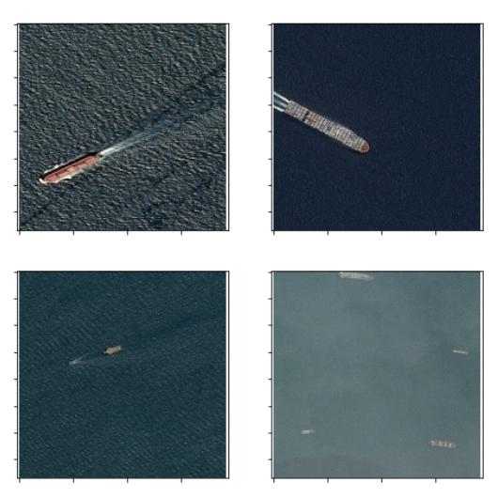

Sample Images without ships

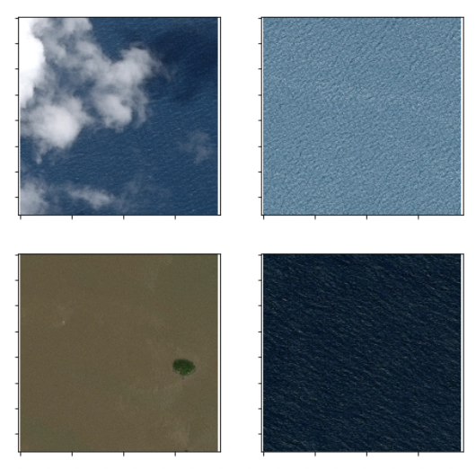

API FUNCTIONS：

Function 1: Get Image and Masks

File Name: findMasks

Function Name: img_and_masks

**Description:**

|  |  |
| --- | --- |
| Input | IMAGEID:  A string that contains the file name of the image in dataset;  ImgShape was set to default as 768 by 768 |
| OUTPUT | A NumPy array represents the original image, all_masks: a numpy array represents the mask of the image |
| Error Handeling | If the name of the iamge file is invalid, return "No such key! Please enter a valid image name!" |

**Example:**

Input: 000155de5.jpg

Output:

Input: 123

Output:

API FUNCTIONS：

Function 2: Get Run Length Decode

File Name: decode

Function Name: rle_decode

**Description:**

|  |  |
| --- | --- |
| Input | mask_rle: run-length as string formated (start length)  shape was set to default as 768 by 768 |
| OUTPUT | numpy array, 1 - mask, 0 - background |
| Error Handeling | "Error Messages: ": "The input run-length string cannot be decode" |

Example:

Input: 477152 1 477919 3 478686 5 479453 7 480222 7 480991 7 481760 7 482530 6 483299 4 484068 3 484837 1

Output:

Input: abc

Output:

API FUNCTIONS：

Function 3: Get ship and non-ship image

**Description:**

|  |  |
| --- | --- |
| Input | A string 'ship' or 'noship' |
| OUTPUT | One of the images' name with ship(s) or noship in our dataset if input is 'ship' or 'noship', respectively. |
| Error Handeling | "Error Messages: ": "No such key! Please enter a valid image name!" |

**Example**

Input: ship

Output:

Input: 123

Output:

API FUNCTIONS：

Function 4: Get the Number of images that has certain number of ships

File Name: image_number_of_ship

Function Name: image_num_ships

**Description:**

|  |  |
| --- | --- |
| Input | An integer: number of ships in an image |
| OUTPUT | How many images in our dataset with this certain number of ships |
| Error Handeling | "Error Messages: ": "Error! " + str(num) + " is not an integer between 0-" + str(m) + "." |

**Example:**

Input: 6

Output:

Input: 25

Output:

API FUNCTIONS：

Function 5: Get Image Directly from S3

File Name: readImageFromS3

Function Name: readImage_S3

**Description:**

|  |  |
| --- | --- |
| Input | Any image file name in the dataset |
| OUTPUT | The numpy array of the image pixles |
| Error Handeling | "Error Messages: ": "No such key! Please enter a valid image name!" |

**Example:**

Input: 0a0eeaaf7.jpg

Output:

Input: abc123

Output:

API FUNCTIONS：

Function 6: Get the number of ships in a certain image

File Name: num_ship_image

Function Name: num_ship_in_image

**Description:**

|  |  |
| --- | --- |
| Input | A string that contains the image file name in the image in dataset. |
| OUTPUT | An integer represents how many ships are there in this image. |
| Error Handeling | "Error Messages: ": "No such key! Please enter a valid image name!" |

**Example:**

Input: 0a2e15e29.jpg

Output:

Input: 123

Output:

